Day – 1 SQL Challenge

Day-1 Challenge:
List all unique hospital services available in the hospital.
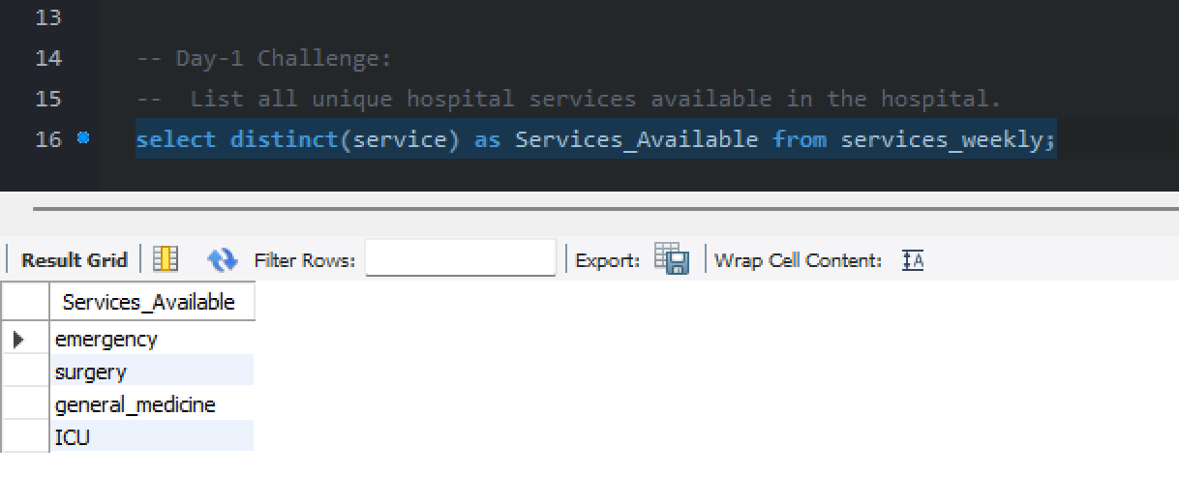

Practice Questions:
1.Retrieve all columns from the patients table.
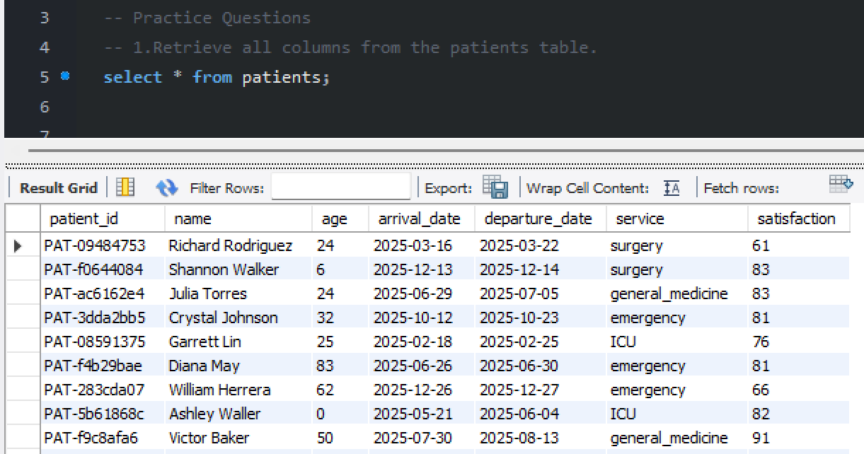

2.Select only the patient_id, name, and age columns from the patients table.
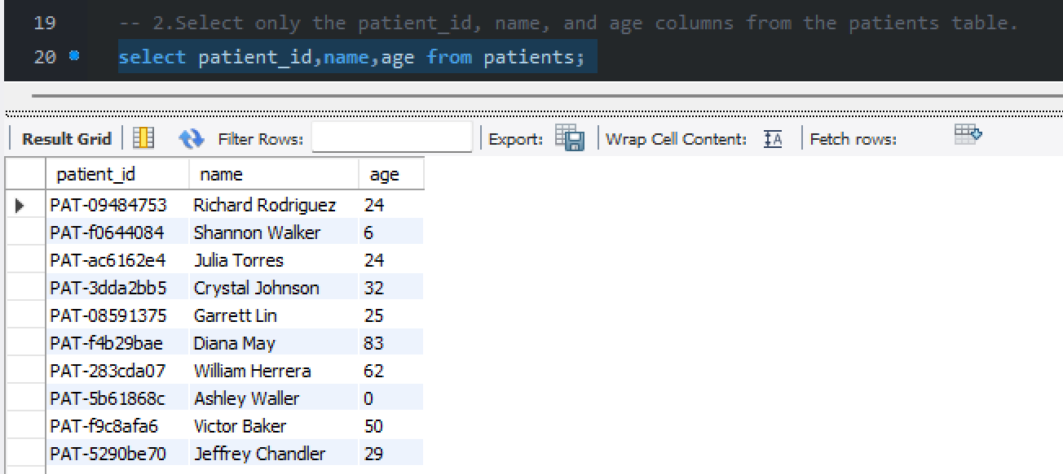

3.Display the first 10 records from the services_weekly table.
